**External and Internal Non-competitive Requisitions (General Posting Information)**

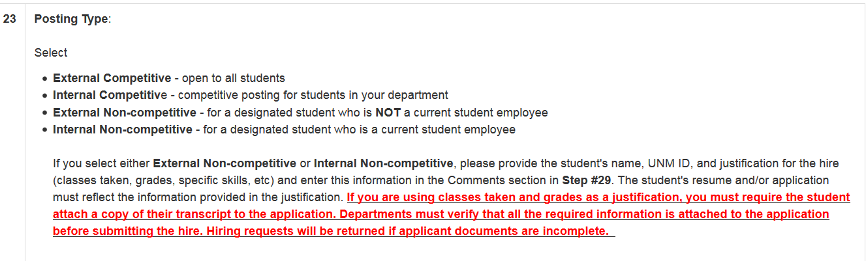

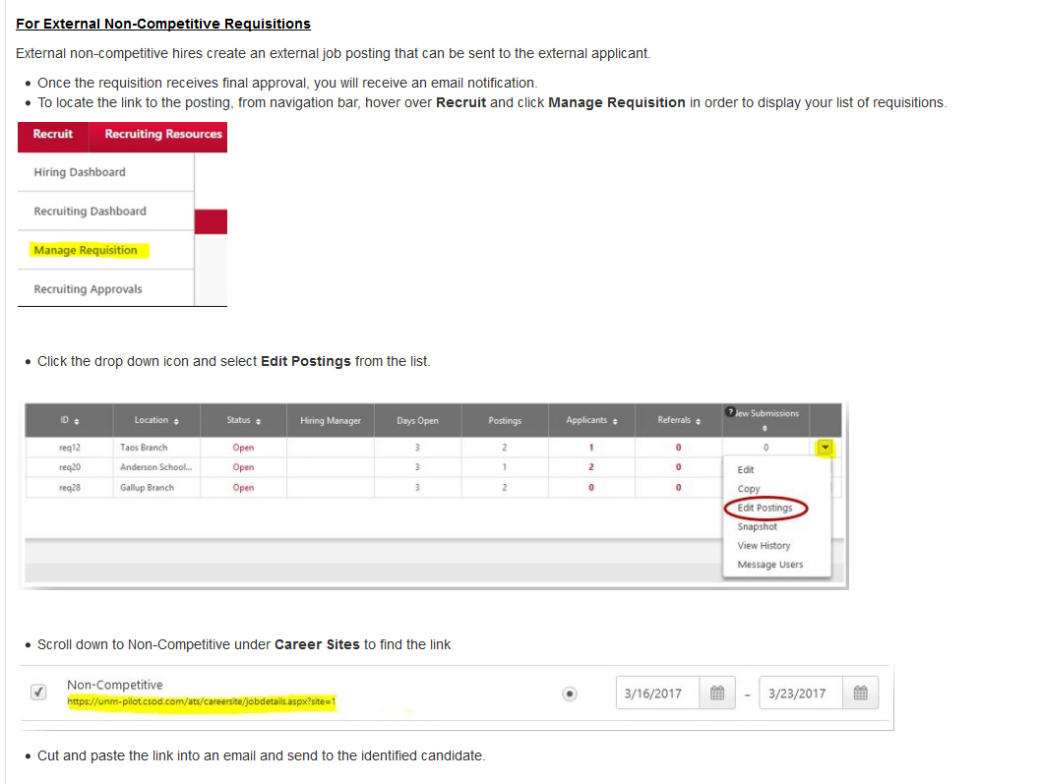

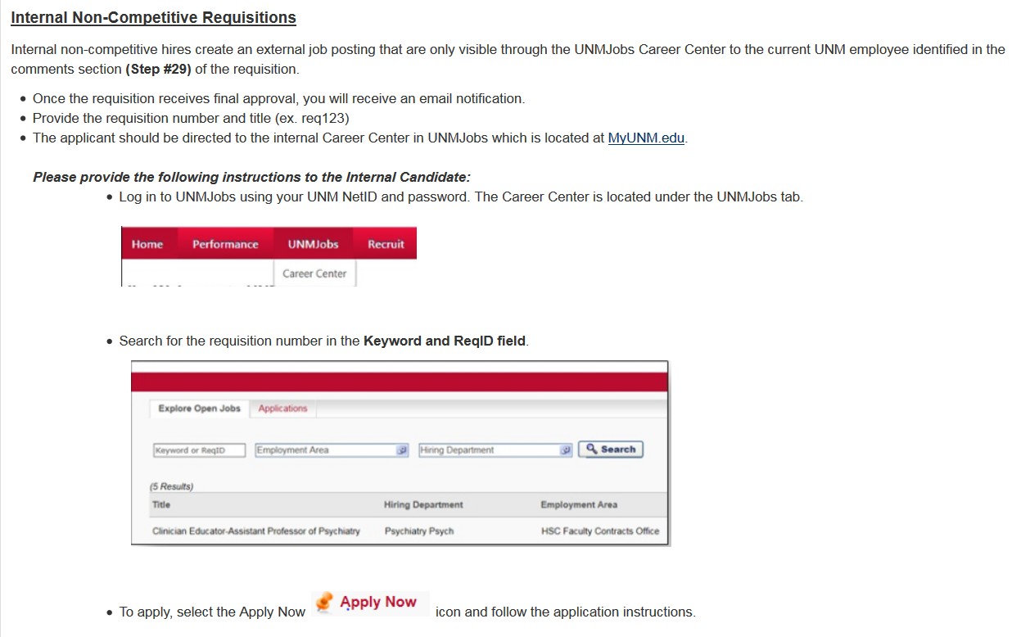

**External and Internal Non-competitive Hiring Requisitions (General Offer Letter Information)**

