Space Request Form

INSTRUCTIONS:
Before Units submit this space request form, the form should be fully vetted by all pertinent parties to ensure the accuracy of the request. Also, Unit Heads should ensure that the majority of the faculty are in agreement with the request.
This application will not be reviewed by the Space Allocation Committee until an inventory of all the space currently being used by the department/center is completed by the College and provided to the Space Allocation Committee.
Any classrooms, offices, or laboratories that are vacated in order to accommodate the space allocation request will become a part of the inventory of available space in the College until the space is otherwise assigned by the College.
Complete this form and attach any additional information. Should any additional questions arise, or if you need further assistance or clarification, please email CASspace@unm.edu

GENERAL INFORMATION:

Requesting Group: Group

Requestor Contact: Requestor

Phone: phone# Email: email

Date of this request: Date

Date Space Needed: Date needed
Requested Duration: Duration
Surge (1-3 Yrs.): ☐ Temporary (3-5 Yrs.): ☐ Permanent: ☐
From: Start date To: End date

SPACE REQUEST INFORMATION:
- Complete the following:
Mark how the space with be utilized.
Relocation of existing space for a given function ☐
Additional space for existing function ☐
Additional space for new function ☐

What is the purpose of the space request?
Instruction ☐ Research ☐ Administration ☐ Auxiliary ☐

Office space: (How many people will need space in each category?)
Faculty Director Support/Admin Post Doc GTA/GRA

Technician Undergrad Other

Space Requested Space Type:
Dry Lab ☐ Wet Lab ☐ Storage ☐ Classroom/Class Lab ☐
Other ☐
How specialized does the space need to be? (Computers, dark, climate control, vibration sensitivity, networking, power configuration, etc. Briefly describe in 50 words or less)
Click or tap here to enter text.
Please include any relevant documentation regarding equipment or instrument specifications (e.g. magnets, lasers, freezers, wet lab space, tissue culture hoods, animal, instrumentation, light proof laboratory, etc.)
Click or tap here to enter text.

- Please describe the name of the person or program that will be occupying the newly requested space, the reason why the space is being requested and the proposed functional use of the space. Is this expected to increase in the next 3-5 years? Explain.
Click or tap here to enter text.
- If this request is based on the award of a research grant that has been funded, please provide the date of the award, term and project number, and amount of funding.
Click or tap here to enter text.
- If this request is based on the award of research grant that has not been funded, please indicate anticipated date for receipt of funding, proposal number, and the anticipated term of the funding.
Click or tap here to enter text.
- Please list the FTE and headcount for faculty, staff and/or graduate students who will be using the requested space, and describe the nature of their position, e.g., program director, principal investigator, technical, administrative assistant, clerical, etc.
Click or tap here to enter text.
- How would your unit be affected if the requested space is not assigned? Click or tap here to enter text.
- Does the requesting unit have operational and/or facilities funding in place? Yes ☐ No ☐
Details, if applicable: Details
- How will your program be affected if this request for space is not approved?
Click or tap here to enter text.
- Describe how you have attempted to locate space within your current allocation? For example: has the department considered reclaiming under-utilized space to solve this need? Have you discussed possibilities for obtaining the space with the current space owner?
Click or tap here to enter text.

- Will existing space be vacated if this request is approved? ☐ Yes ☐ No
If “yes”, please attach a specific list of the building, floor and room(s) to be vacated.
Click or tap here to enter text.
If “no”, please state what your existing space will be used for in the future.
Click or tap here to enter text.

- Please list any adjacency or proximity considerations.
Click or tap here to enter text.

- What steps have been taken to solve the space requirement by the reassignment of existing space within the Department? For example: has the department considered reclaiming under-utilized space to solve this need?
Click or tap here to enter text.
- Please provide any additional information that will support or better define this space request.
Click or tap here to enter text.

The signatures below indicate agreement that this space request should be reviewed. Approval to proceed with the analysis of this request does not imply any commitment for the assignment of space.

Chair / Director / PI
Signature Date:

CAS Space Allocation

Committee Chair
Signature Date:

Dean / Assistant Dean
Signature Date:

BUILDING INFORMATION
Building Name and Number for this Space Request: Click or tap here to enter text.

Room(s) Requested: Click or tap here to enter text.

Insert Floor Plan from FAMIS Cloud Visual map, showing allocated groups: (identify space being requested)

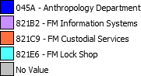
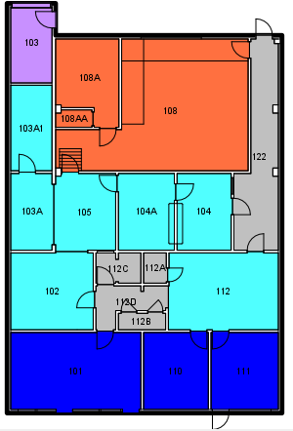
- Example Department 1
- Example Department 2
- Example Department 3
- Example Department 4 COMMON SPACE
Requested space
by Example Department

